Avoid overlap with parts A & B as I will not mark repeated evidence

PART A (15%): Short Answer Pick 3 terms and write a large paragraph for each. (5% each) Do Not write more than 3 terms!

- Define fully and give the significance of 3 of the following terms, people, events or phrases.
- Why is this term important to the study of Women’s History?

- Les Filles du Roi
- Triangle Factory Fire

“Ain’t I a Woman?”
- Mock Parliament
- The Feminine Mystique

- Sarah Gayle & Rose
- Madam C.J. Walker
- Quintland
- Veronica the Bren Gun Girl
- Kleptomania
- “We Will Work Again”
- “Case of the Kissing Nurse”
- “The Proudest Girl in the World”

- Freedom Trash Can
- Septima Poinsette Clark

PART B (5%): Deconstruct Primary Source— Short Essay (1 image, 250-300 words (1 page Single Spaced)

To critically examine this document question who produced it and for what purpose. Can you detect the author’s bias? How did the political, social, racial, or economic climate of the time impact (if at all) the writer’s motives, or how they thought? How would these same issues have influenced the way the document was received? What is the tone of the document? What larger themes does it speak to in North American women’s history? How does it contribute to historiography? Use course materials and online readings whenever possible to substantiate your observations and strengthen your arguments.
Images on Next Page, Choose either A OR B.

A) Norman Rockwell, The Saturday Evening Post (May 29, 1943).

B) Anti-Suffrage postcard: "What is a Suffragette without a Suffering Household?" Copyright 1909 by Dunston-Weiler Lithograph Co., NY

Avoid overlap with parts A & B as I will not mark repeated evidence

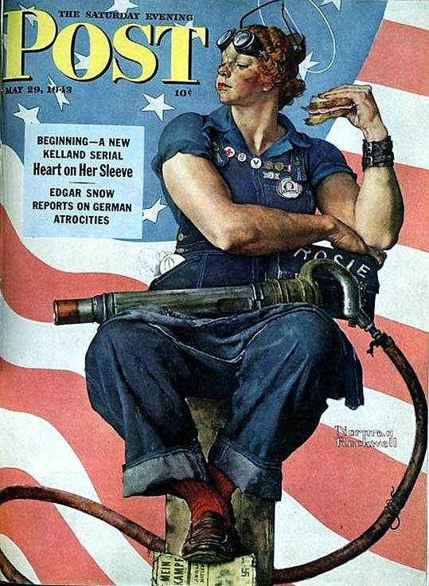

B
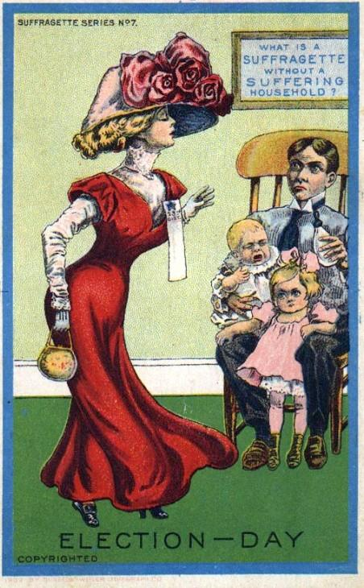

PART C: Long Essay Question (1 essay, 650- 750 words, ~ 2-3 pages, 10%):

- Answers should incorporate a variety of online readings and course materials.

- Use at least four (4) different time periods discussed in the powerpoints. (Use the powerpoints that I have provided to answer this essay question. Make sure you site every source, only use the material that’s provided in the powerpoints

- Avoid unnecessary overlap with parts 1 & 2.

- Remember to be as specific as possible & support your argument with detailed examples as evidence.

- Cite your sources as all answers will be scanned through Safe Assign.

Avoid overlap with parts A & B as I will not mark repeated evidence

PART C: Long Essay Question

ESSAY QUESTION: History has often portrayed women as victims who are trapped into passivity by the ideology of separate spheres. Others have argued that biology alone is responsible for women’s status in society. Is there room for another interpretation? What examples, if any, are there to suggest that women played an active role in shaping their own social and political status in North America?
You can use this video to answer this questions as well.
https://www.youtube.com/watch?v=UQiqMgD5C6Y

